**Nandha_FDP_Python_day 4_Files  
Question 4**

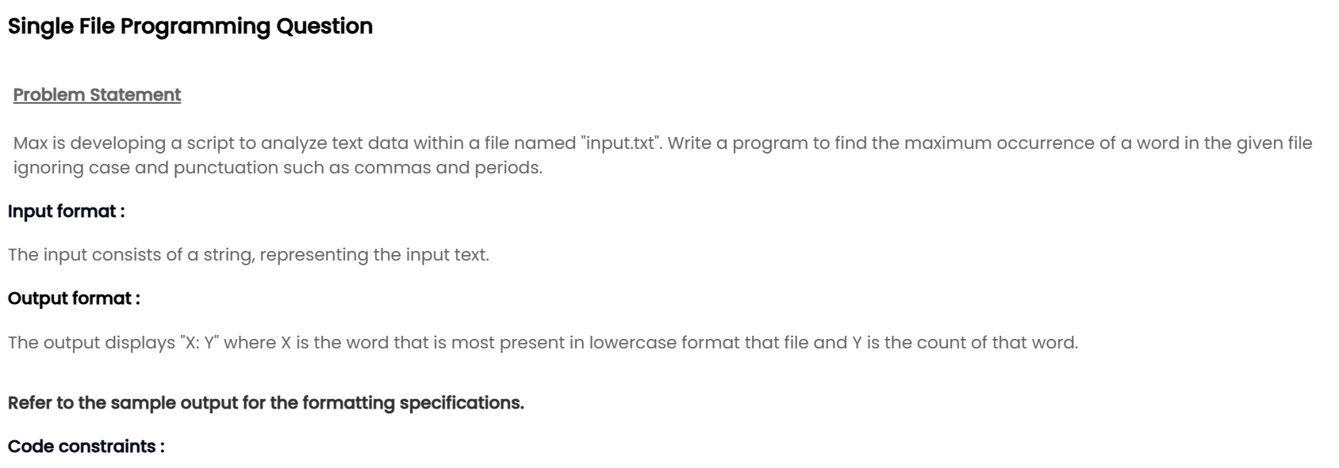

**Nandha_FDP_Python_day 4_Function Basics  
Question 3**

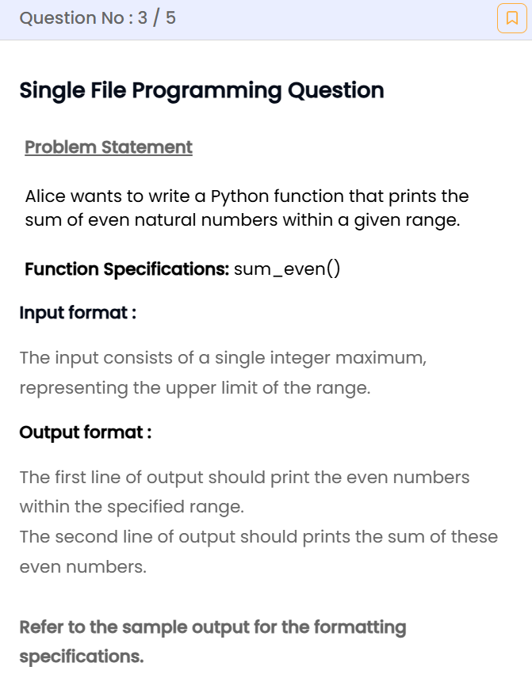

Nandha_FDP_Python_day 4_Pass by reference  
